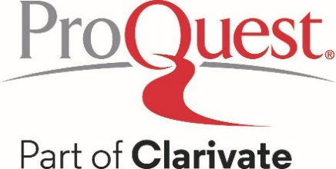

Suggested Social Media Posts to promote ProQuest History Vault™

- Step back in time with ProQuest History Vault! Explore incredible primary sources that shed light on both well-known and lesser known moments in history. Discover history as it happened with this collection. #HistoryVault #PrimarySources #HistoryUncovered

- Calling all history students, enthusiasts, and scholars! ProQuest History Vault offers access to vast archive of historical primary source documents. Dive into the past, learn from the experts, and expand your historical knowledge with these invaluable resources. #HistoryVault #PrimarySources #HistoryUncovered

- Explore history like never before with ProQuest History Vault. Our featured collection delves deep into the vault, the History Vault. Delve into pivotal moments in history with this collection. #HistoryVault #PrimarySources #HistoryUncovered

- Unearth the Past! ProQuest History Vault opens the door to pivotal moments in history with award-winning digitized collections, providing an intimate look through first-hand accounts, declassified documents, and personal letters. #PrimarySources #HistoryVault

- Step into History! ProQuest History Vault brings major archival collections to your fingertips, offering unique primary sources for students and researchers to delve into the heart of significant events. #ExploreHistory #ResearchSkills

- ProQuest History Vault is your key to major archival collections, offering an unparalleled opportunity to examine widely studied topics and lesser-known events through primary sources. #HistoricalInsights #ResearchJourney

- From the Archives to You: ProQuest History Vault delivers award-winning digitized collections, giving students and researchers a front-row seat to history through personal letters, business ledgers, and declassified government documents. #HistoryUncovered #PrimarySourceExperience

- Dive deep into America's rich tapestry of history with ProQuest History Vault! Uncover the untold stories and pivotal moments across a vast array of subjects: slavery, civil rights, women’s studies, labor rights, Latino history, Native American history, American politics, and more. Unearth the past, challenge perspectives, and expand your knowledge! #HistoryVault #DiscoverHistory

