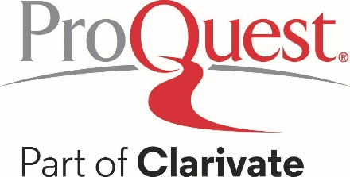

Suggested Social Media Posts to promote HeritageQuest® Online

- Interested in knowing where your ancestors were born? Or when they immigrated to different countries?

Start searching with HeritageQuest Online here [library access link]!

- Use birth, marriage, death records, and censuses to gather additional details about your ancestor’s spouse to see if you’ve landed on a great story about how your ancestor married the girl (or boy) next door.

Learn more about your ancestors here [library access link]!

- With HeritageQuest Online access [library access link] 500+ searchable databases for genealogical research, containing more than 5 billion total records.

- Your ancestors left clues along the way. Now, you can trace them online.

Access HeritageQuest Online for free here [library access link]!

- HeritageQuest Online makes it convenient to explore billions of American and international genealogical records dating back to the 1700s — including unique primary sources, family and local histories, research guides, interactive census maps and more.

Access it for free here [library access link]!

- Here [library access link], you can unlock the story of you with sources like censuses, vital records, immigration records, family histories, military records, court and legal documents, directories, photos, maps, and more.

- Combined with an easy to use search experience, it’s easier than ever for users to discover their ancestors and learn about local people and places from the past.

Access HeritageQuest Online for free here [library access link]!

- Explore the amazing history of you. Access HeritageQuest Online for free here [library access link]!

