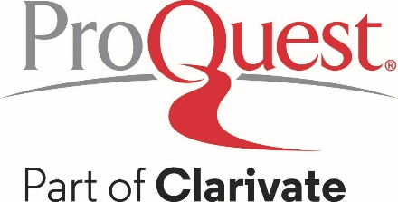

Suggested Social Media Posts to promote Ancestry® Library Edition

- Interested in knowing where your ancestors were born? Or when they immigrated to different countries?

Ask us about Ancestry Library Edition the next time you visit!

- Use birth, marriage, death records, and censuses to gather additional details about your ancestor’s spouse to see if you’ve landed on a great story about how your ancestor married the girl (or boy) next door.

Learn more about your ancestors here!

- Looking to put together your family tree? Download an ancestral chart and fill-in your family tree with what you know about your parents, grandparents, etc.

Start your ancestral chart at Ancestry Library Edition, which you can access for free at the library!

- Your ancestors left clues along the way. Now, you can trace them online at the library.

Ask us about Ancestry Library Edition the next time you visit!

- Ancestry Library Edition is the world’s most popular consumer online genealogy resource. It’s an unprecedented online collection of individuals from North America, the United Kingdom, Europe, Australia, and more.

Access it today for free at [library name]!

- At [library name], you can unlock the story of you with sources like censuses, vital records, immigration records, family histories, military records, court and legal documents, directories, photos, maps, and more.

- User-friendly search tools and comprehensive indexing make it easy to start discovering personal histories.

Access Ancestry Library Edition for free at [library name]!

- Explore the amazing history of you. Access Ancestry Library Edition for free at [library name]!

