New Library Resource: ProQuest One Business
The Library team is pleased to share that our business students and researchers now have access to ProQuest One Business.

What is ProQuest One Business?
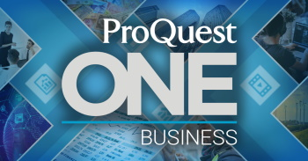
ProQuest One Business is a new resource designed to meet the research needs of business faculty and students.
A business-focused interface intuitively guides users to content like journal articles, books, and company, industry and country reports – the materials you need for your most common assignments. Company Overview pages help you quickly find the best resources for in-depth company research, including SWOT analyses, financial information, and current articles.

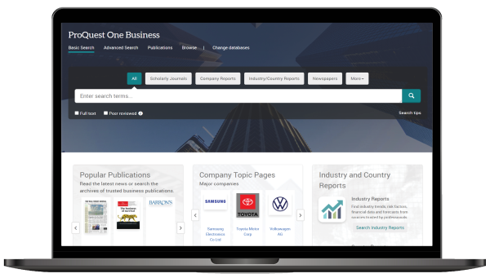
How to access and browse?
ProQuest One Business can be accessed here [link] and via the Library Catalogue / A-Z Resource List (institution log-in may be required). Once authenticated, library users can explore the wealth of content and a mix of practical and theoretical content in an interface that helps build the research skills students need for success in their courses and careers.
.
Explore this unique database today and amplify your classroom discussions, curriculum and assignments.
The Library Team

